**Hello World RESTful Web Service**

**Codes:**

**HelloController.java:**

**package** com.cognizant.spring_learn.controller;

**import** org.slf4j.Logger;

**import** org.slf4j.LoggerFactory;

**import** org.springframework.web.bind.annotation.GetMapping;

**import** org.springframework.web.bind.annotation.RestController;

@RestController

**public** **class** HelloController {

**private** **static** **final** Logger ***LOGGER***=LoggerFactory.*getLogger*(HelloController.**class**);

@GetMapping("/hello")

**public** String sayHello() {

***LOGGER***.info("START - sayHello()");

String message="Hello World!!";

***LOGGER***.info("END - sayHello()");

**return** message;

}

}

**SpringLearnApplication.java:**

**package** com.cognizant.spring_learn;

**import** org.slf4j.Logger;

**import** org.slf4j.LoggerFactory;

**import** org.springframework.boot.SpringApplication;

**import** org.springframework.boot.autoconfigure.SpringBootApplication;

@SpringBootApplication

**public** **class** SpringLearnApplication {

**private** **static** **final** Logger ***LOGGER***=LoggerFactory.*getLogger*(SpringLearnApplication.**class**);

**public** **static** **void** main(String[] args) {

***LOGGER***.info("Main method started...");

SpringApplication.*run*(SpringLearnApplication.**class**, args);

***LOGGER***.info("Application running");

}

}

**application.properties:**

spring.application.name=spring-learn

server.port=8083

**Output:**

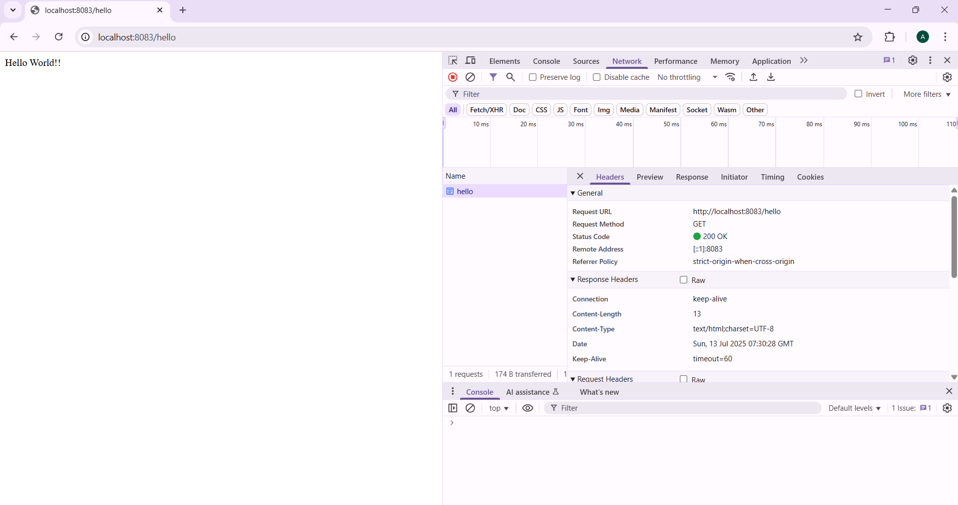

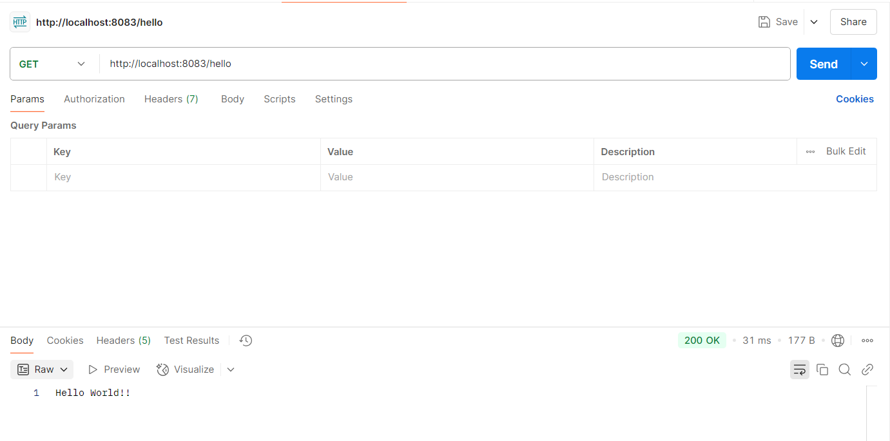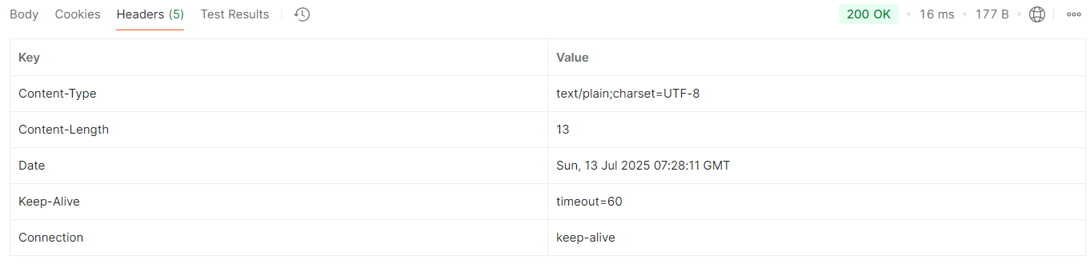

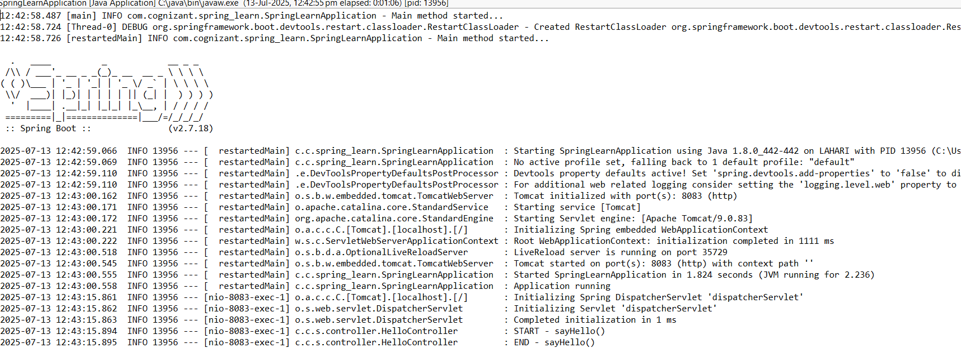

**REST - Country Web Service**

**Codes:**

**Country.java:**

**package** com.cognizant.spring_learn;

**import** org.slf4j.Logger;

**import** org.slf4j.LoggerFactory;

**public** **class** Country {

**private** **static** **final** Logger ***LOGGER***=LoggerFactory.*getLogger*(Country.**class**);

**private** String code;

**private** String name;

**public** Country() {

***LOGGER***.debug("Inside Country Constructor");

}

**public** String getCode() {

***LOGGER***.debug("Getting country code");

**return** code;

}

**public** **void** setCode(String code) {

***LOGGER***.debug("Setting country code");

**this**.code=code;

}

**public** String getName() {

***LOGGER***.debug("Getting country name");

**return** name;

}

**public** **void** setName(String name) {

***LOGGER***.debug("Setting country name");

**this**.name=name;

}

@Override

**public** String toString() {

**return** "Country [code="+code+", name="+name+"]";

}

}

**SpringLearnApplication.java:**

**package** com.cognizant.spring_learn;

**import** org.slf4j.Logger;

**import** org.slf4j.LoggerFactory;

**import** org.springframework.boot.SpringApplication;

**import** org.springframework.boot.autoconfigure.SpringBootApplication;

@SpringBootApplication

**public** **class** SpringLearnApplication {

**private** **static** **final** Logger ***LOGGER***=LoggerFactory.*getLogger*(SpringLearnApplication.**class**);

**public** **static** **void** main(String[] args) {

***LOGGER***.info("Main method started...");

SpringApplication.*run*(SpringLearnApplication.**class**, args);

***LOGGER***.info("Application running");

}

}

**CountryController.java:**

**package** com.cognizant.spring_learn.controller;

**import** com.cognizant.spring_learn.Country;

**import** org.slf4j.Logger;

**import** org.slf4j.LoggerFactory;

**import** org.springframework.context.ApplicationContext;

**import** org.springframework.context.support.ClassPathXmlApplicationContext;

**import** org.springframework.web.bind.annotation.RequestMapping;

**import** org.springframework.web.bind.annotation.RestController;

@RestController

**public** **class** CountryController {

**private** **static** **final** Logger ***LOGGER***=LoggerFactory.*getLogger*(CountryController.**class**);

@RequestMapping("/country")

**public** Country getCountryIndia() {

***LOGGER***.info("START - getCountryIndia()");

ApplicationContext context=**new** ClassPathXmlApplicationContext("country.xml");

Country country=context.getBean("country",Country.**class**);

***LOGGER***.info("END - getCountryIndia()");

**return** country;

}

}

**country.xml:**

<?xml version="1.0" encoding="UTF-8"?>

<beans xmlns="http://www.springframework.org/schema/beans"

xmlns:xsi="http://www.w3.org/2001/XMLSchema-instance"

xsi:schemaLocation="http://www.springframework.org/schema/beans

https://www.springframework.org/schema/beans/spring-beans.xsd">

<bean id="country" class="com.cognizant.spring_learn.Country">

<property name="code" value="IN" />

<property name="name" value="India" />

</bean>

</beans>

**Output:**

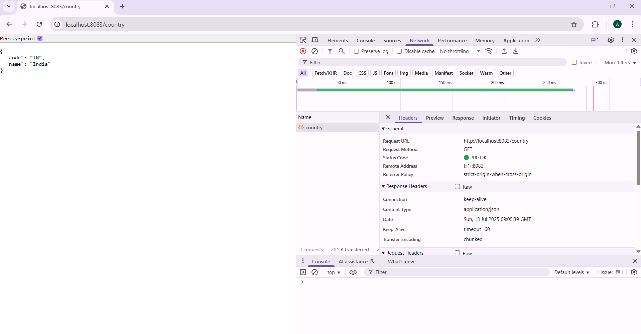

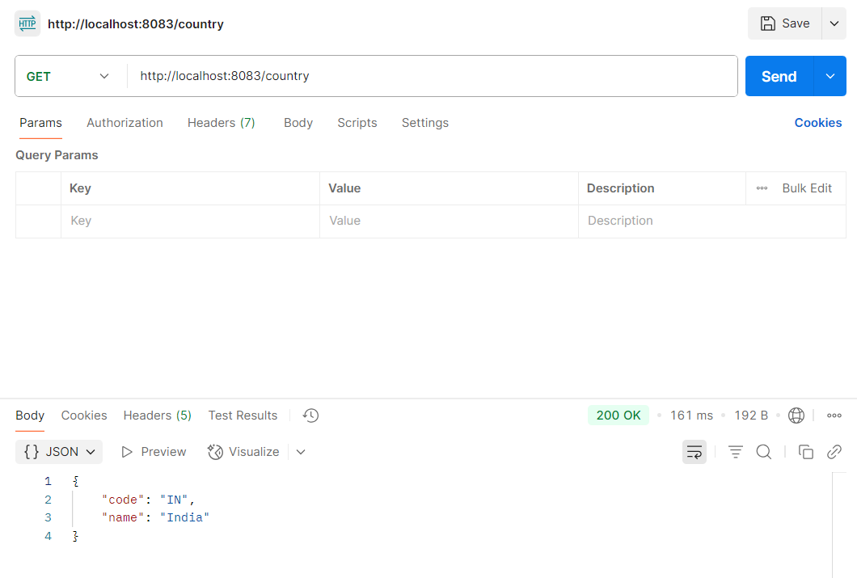

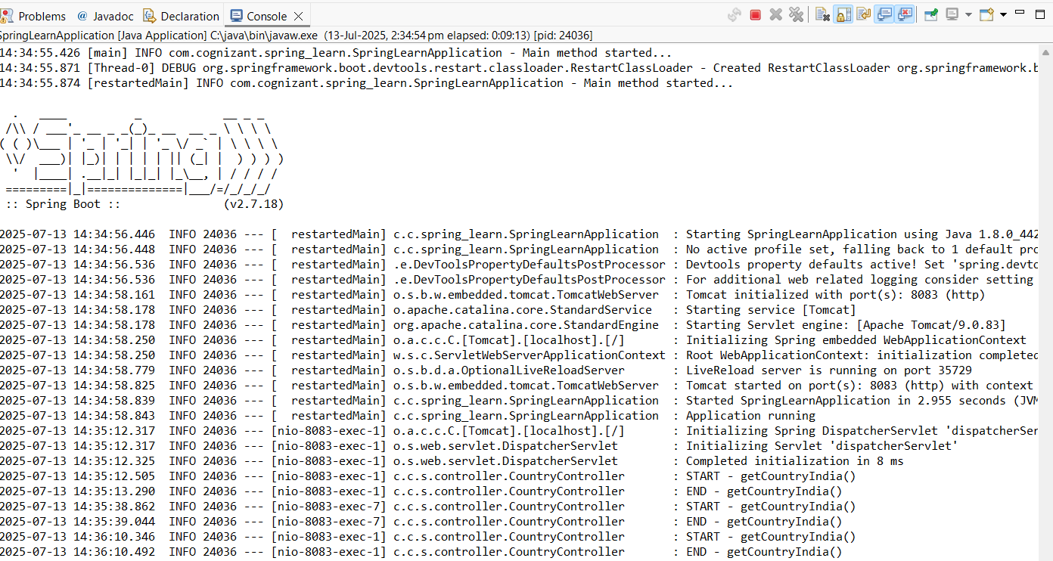

**REST - Get country based on country code**

**Codes:**  
**CountryController.java:**

**package** com.cognizant.spring_learn.controller;

**import** com.cognizant.spring_learn.Country;

**import** com.cognizant.spring_learn.service.CountryService;

**import** org.slf4j.Logger;

**import** org.slf4j.LoggerFactory;

**import** org.springframework.beans.factory.annotation.Autowired;

**import** org.springframework.web.bind.annotation.*;

@RestController

**public** **class** CountryController {

**private** **static** **final** Logger ***LOGGER***=LoggerFactory.*getLogger*(CountryController.**class**);

@Autowired

**private** CountryService countryService;

@GetMapping("/countries/{code}")

**public** Country getCountry(@PathVariable String code) {

***LOGGER***.info("START - getCountry() with code: {}",code);

Country country=countryService.getCountry(code);

***LOGGER***.info("END - getCountry() with result: {}",country);

**return** country;

}

}

**CountryService.java:**

**package** com.cognizant.spring_learn.service;

**import** com.cognizant.spring_learn.Country;

**import** org.slf4j.Logger;

**import** org.slf4j.LoggerFactory;

**import** org.springframework.context.ApplicationContext;

**import** org.springframework.context.support.ClassPathXmlApplicationContext;

**import** org.springframework.stereotype.Service;

**import** java.util.List;

@Service

**public** **class** CountryService {

**private** **static** **final** Logger ***LOGGER***=LoggerFactory.*getLogger*(CountryService.**class**);

**public** Country getCountry(String code) {

***LOGGER***.info("START - getCountry()");

ApplicationContext context=**new** ClassPathXmlApplicationContext("country.xml");

List<Country> countryList=context.getBean("countryList",List.**class**);

Country result=countryList.stream()

.filter(country -> country.getCode().equalsIgnoreCase(code))

.findFirst()

.orElse(**null**);

***LOGGER***.info("END - getCountry()");

**return** result;

}

}

**country.xml:**  
<?xml version="1.0" encoding="UTF-8"?>

<beans xmlns="http://www.springframework.org/schema/beans"

xmlns:xsi="http://www.w3.org/2001/XMLSchema-instance"

xsi:schemaLocation="http://www.springframework.org/schema/beans

https://www.springframework.org/schema/beans/spring-beans.xsd">

<bean id="countryList" class="java.util.ArrayList">

<constructor-arg>

<list>

<bean class="com.cognizant.spring_learn.Country">

<property name="code" value="IN" />

<property name="name" value="India" />

</bean>

<bean class="com.cognizant.spring_learn.Country">

<property name="code" value="US" />

<property name="name" value="United States" />

</bean>

<bean class="com.cognizant.spring_learn.Country">

<property name="code" value="DE" />

<property name="name" value="Germany" />

</bean>

<bean class="com.cognizant.spring_learn.Country">

<property name="code" value="JP" />

<property name="name" value="Japan" />

</bean>

</list>

</constructor-arg>

</bean>

</beans>

**Output:**

